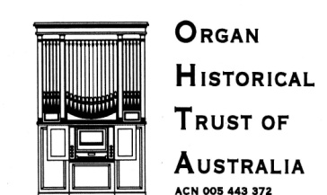
PO BOX 200 CAMBERWELL VICTORIA 3124
40TH ANNIVERSARY CONFERENCE 25- 30 SEPTEMBER 2017
XX January 2017
Dear....................
At the end of September 2017, the Organ Historical Trust of Australia will be celebrating its 40th anniversary during a six-day conference. We are anticipating that there will be a large number of participants from throughout Australia, New Zealand, Europe and America. During the conference, we will be listening to papers on key topics as well as visiting significant examples of pipe organs in the Melbourne and Ballarat areas.
We are writing to ask if it may be possible to visit ............................ on ......September 2017 at ..... to see and hear the pipe organ. The instrument would be demonstrated by an expert performer and a brief talk would be given on its history and construction. Members of your congregation would be most welcome to attend. The duration of the visit would be around one hour.
In order to assist with ongoing planning, we should appreciate your advice on whether this visit would be possible at the nominated time, preferably within the next fortnight.
We would be pleased to make a donation for the visit and to hand over a copy of our conference book for your archives.
Our website is at www.ohta.org.au
Many thanks for your advice.

Yours sincerely,
..............................
(on behalf of the Conference Planning Committee)

(Please reply to …)

